5/23/2023

Aditya Rameshwar Kajale

Attendance Management System

WORKING GUID DOCUMENTATION

INDEX

1. Introduction 1

2. Types of logins 2

2.1 Year Coordinator (Admin) Login 3

2.2 Faculty Login 11

**1. Introduction**

Welcome to the documentation guide for the Attendance Management System (AMS)! This guide will walk you through the steps of using the application effectively, starting from account creation and setup. We will cover user management, attendance taking methods, attendance record and exam marks management. Let's get started!

The documentation will start by providing instructions for accessing the admin login, which allows users to set up other logins within the Attendance Management System (AMS). After the initial setup, users have the option to delete the admin login to enhance security and limit administrative access.

Login Page- The login page in the Attendance Management System (AMS) is the gateway for users to access their accounts. It provides a secure interface where users can enter their login credentials to authenticate their identities and gain access to the system. The login page ensures data privacy and grants users access to their specific roles within the AMS, such as year coordinator(admin), faculty, exam coordinator, student, or master. It plays a vital role in facilitating secure access and efficient attendance record management.

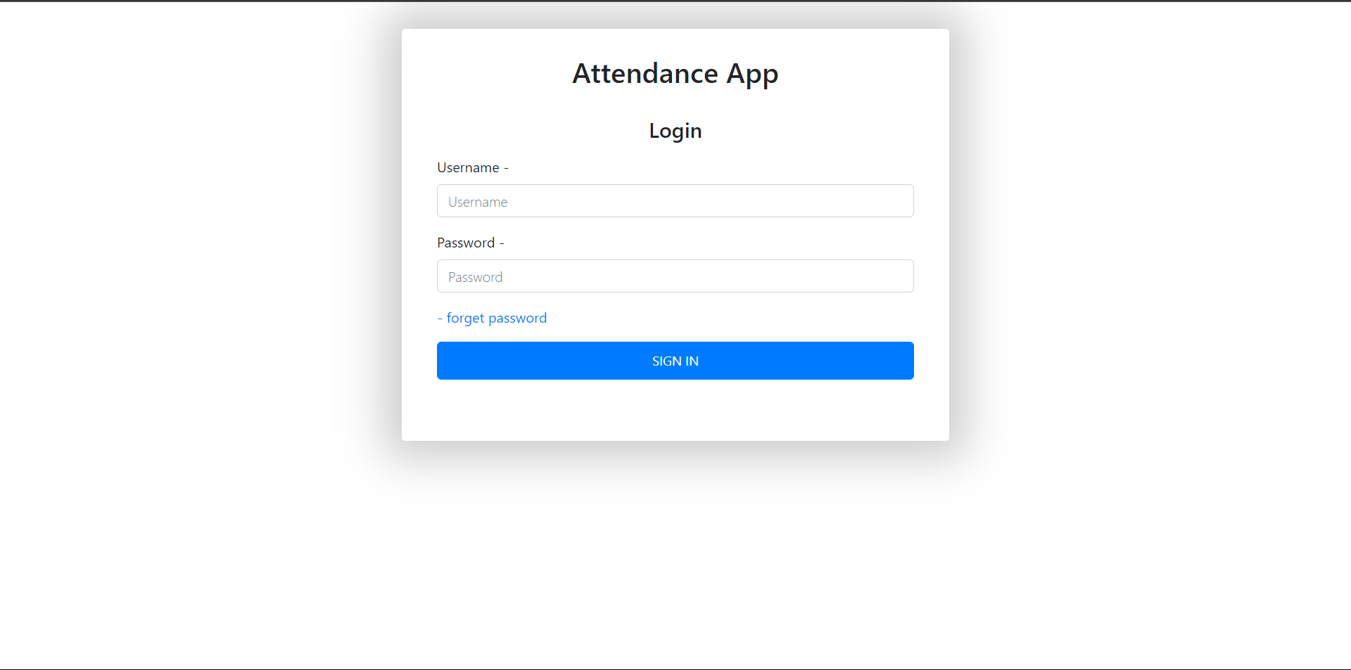

**2. Types of logins**

In the Attendance Management System (AMS), there are five types of logins that cater to different user roles and responsibilities:

1. **Year Coordinator (Admin) Login**: The year coordinator login is similar the admin login. It can create and delete new logins for faculties and year coordinator. As it is year coordinator it has privileges to add class, add new subjects, and delete attendance.
2. **Faculty Login**: The faculty login is designed for teachers who need to mark attendance for their respective classes. It provides access to attendance recording, tracking, and related functionalities.
3. **Exam Coordinator Login**: The exam coordinator login is dedicated to exam coordinators who are responsible for managing marks of examinations. This login allows them to add, remove and edit marks of students respective to class and examination.
4. **Student Login**: The student login is for individual students to view and track their own attendance records. It provides students with a convenient way to stay updated on their attendance status and monitor their attendance progress.
5. **Master Login**: This login has privileges to backup and **clean** all attendance data after the semester ends.

By offering these different login types, the AMS caters to the diverse needs and roles within an organization or educational institution, ensuring efficient and accurate attendance management.

In the following sections, we will provide a comprehensive explanation of each login type in the Attendance Management System (AMS). Accompanied by screenshots, we will walk you through the functionalities and features specific to each login, including year coordinator (admin), faculty, exam coordinator, and student logins. This detailed explanation will help you gain a thorough understanding of how to utilize each login effectively and efficiently manage attendance records within the AMS. Let's dive in!

**2.1 Year Coordinator (admin) login:**

The Year Coordinator Login in the Attendance Management System (AMS) is specifically designed for individuals serving as year coordinators. This login empowers them to manage other logins and all the work of a year coordinator.

The Year Coordinator Login in the Attendance Management System (AMS) provides year coordinators with a range of functions, here are some key functions that year coordinators can perform:

**2.1.1 Manage Faculty:**

Year coordinators have the authority to assign subjects to faculty members, create new faculty profiles, and remove existing faculty from the system.

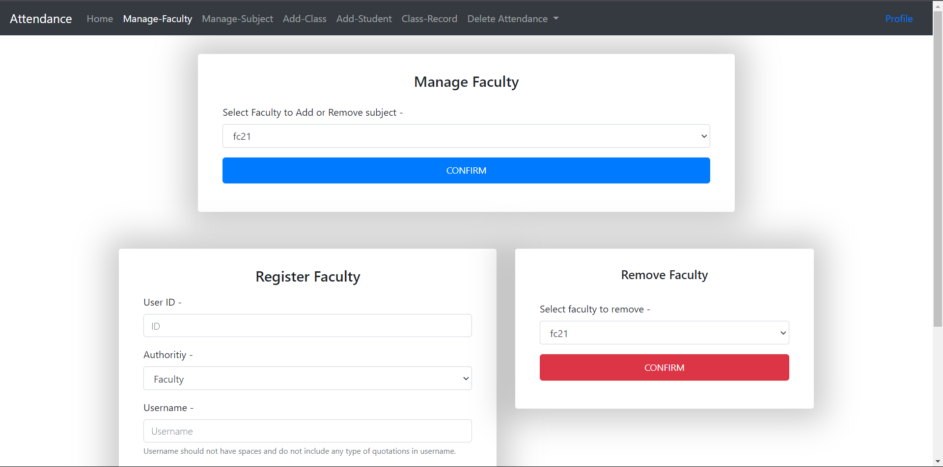

* Manage Faculty - Year coordinators can assign subjects to faculty members within the Attendance Management System (AMS). This function allows them to ensure that each faculty member is assigned the appropriate subjects (theory and practical) they will be teaching for a specific academic year or group.

* Register Faculty: Year coordinators have the authority to create new faculty profiles in the AMS. This function enables them to add the necessary information for new faculty members, such as their username, password, and email.

* Remove faculty: Year coordinators can also delete faculty profiles from the system. This function is useful when faculty members leave the institution or no longer teach specific subjects. Removing their profiles helps maintain an updated and accurate record of the active faculty within the AMS.

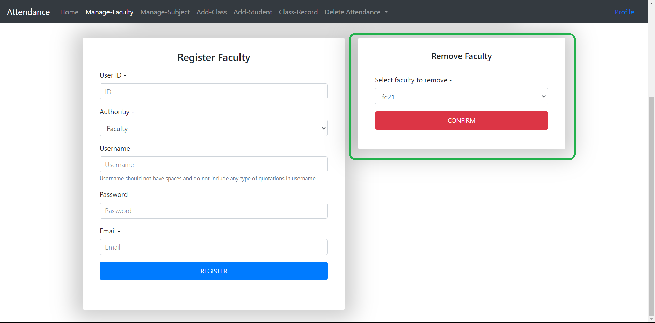

**2.1.2 Manage Subject:**

The Manage Subjects section in the Attendance Management System (AMS) allows users to efficiently handle subjects within the system. This section provides two key functions: adding new subjects and renaming existing ones.

* Add subject: Users have the capability to add new subjects to the AMS. By adding new subjects, users can ensure that the AMS reflects the complete list of subjects offered within their institution or organization.

* Rename Existing Subjects: In situations where subject names need to be updated or modified, the AMS provides the option to rename existing subjects. This function allows users to make necessary changes to subject names without affecting the associated attendance records. It ensures consistency and accuracy in subject information within the system.

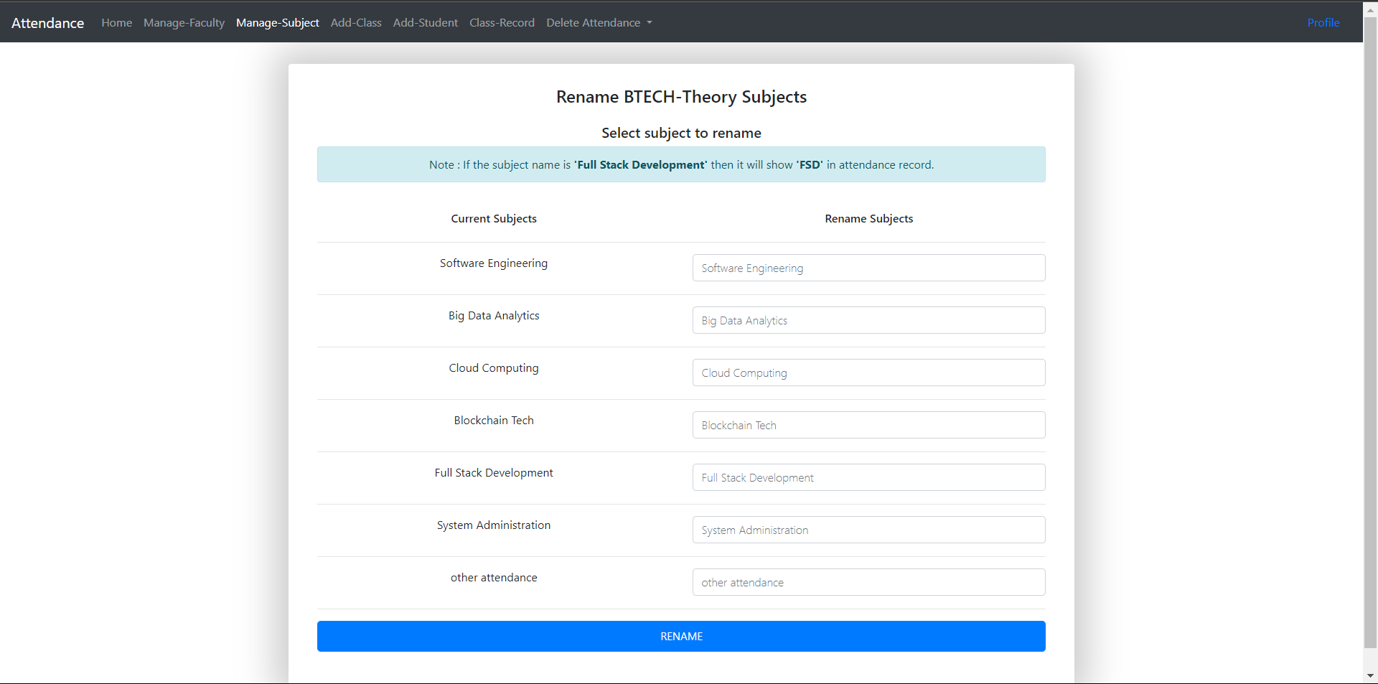

**2.1.3 Add Class:**

*(You need add all the subjects before adding class in application) (In case you added class before adding all subjects, you need to clear all data of that particular year from the MASTER LOGIN and then add remaining subject and add class again.) *

The Add Class section in the Attendance Management System (AMS) provides users with a convenient way to import class information using a CSV (Comma Separated Values) format. This feature simplifies the process of adding multiple classes by allowing users to upload a CSV file containing the necessary details.

To add a class, users first select the appropriate year and division within the AMS application. This selection ensures that the class is correctly associated with the specific academic year and division it belongs to.

By utilizing the Add Class section, users can efficiently add multiple classes to the AMS by simply uploading a CSV file and selecting the appropriate year and division. This streamlines the process of class creation and ensures accurate attendance tracking for each class within the system.

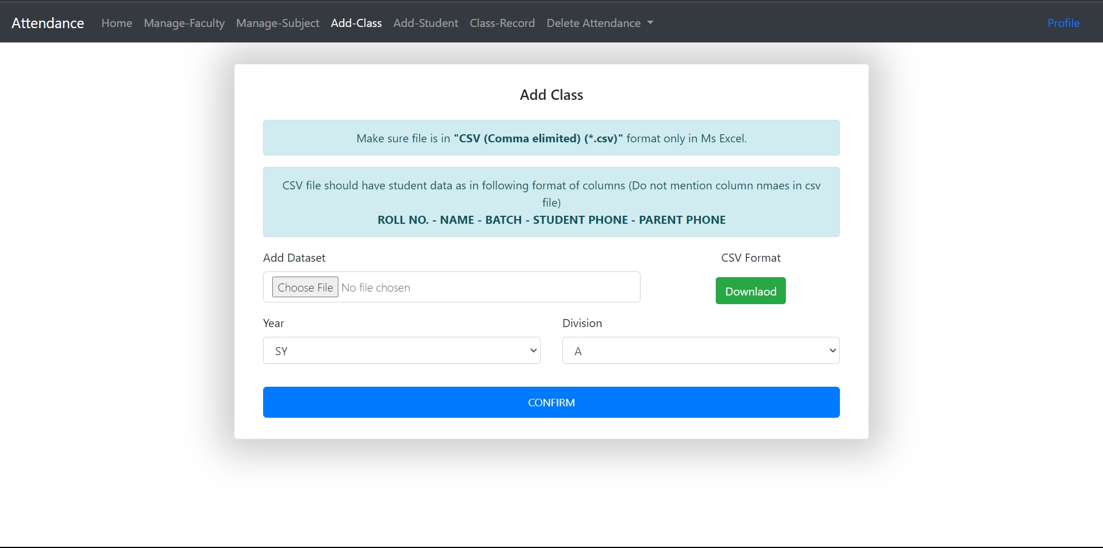

**2.1.4 Add Student:**

The Add Student section in the Attendance Management System (AMS) is specifically designed for cases when a student gets admission after classes have been added using the Add Class section. This feature allows users to easily add individual students to the system and assign them to the appropriate class.

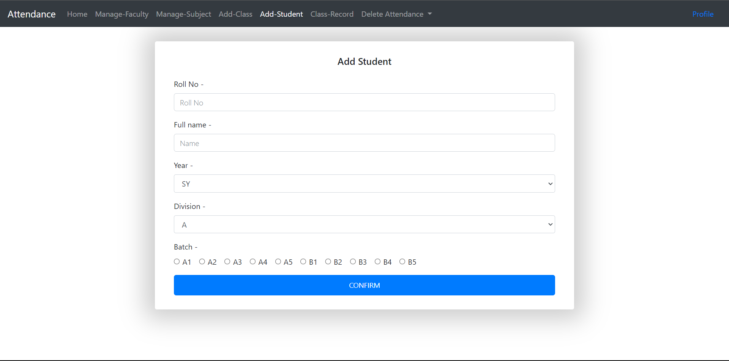

**2.1.5 Display Class:**

The Display Class section in the Attendance Management System (AMS) enables users to access and review the records of students enrolled in a specific class. This section provides a comprehensive view of whether students have been successfully added to the application or not.

**2.1.6 Delete Attendance:**

The Delete Attendance section in the Attendance Management System (AMS) allows users to remove attendance records for a specific day, subject, batch, year, and division. This feature provides flexibility and control in managing attendance data within the system. The Delete Attendance section empowers users to manage attendance records with precision and accuracy, maintaining a reliable and up-to-date representation of attendance data within the AMS.

------------------------------------------------------------------------------------------------

Congratulations! You have reached the end of the Year Coordinator section in the Attendance Management System (AMS) documentation. As a year coordinator, you have learned about the key responsibilities and functionalities associated with this role.